Project Documentation

# Overview

This project is a simple Number Guessing Game implemented in Python. The game generates a random number between 1 and 100, and the user is prompted to guess the correct number. The code provides feedback on whether the guess is too low or too high and congratulates the user upon a correct guess.

Question

# Create a Number Guessing Game in Python.

## Code Logic and Design

The code is structured into a function called start_game, encapsulating the logic of the Number Guessing Game. The game generates a random number, takes user input for guesses, and provides feedback until the correct number is guessed. The script promotes readability through clear variable names and well-commented sections.

# Screenshots with Explanations

## Game Start:

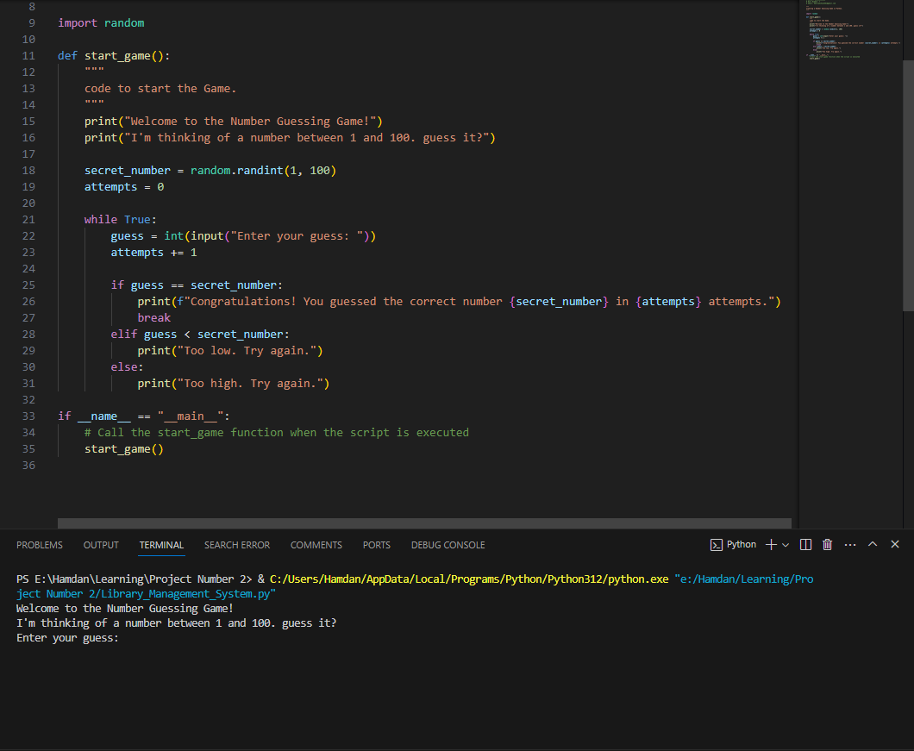

Explanation: In this screen-shot ‘The game welcome you and ask a question to guess a number between 100 to 1 or 1 to 100.

## Correct Guess:

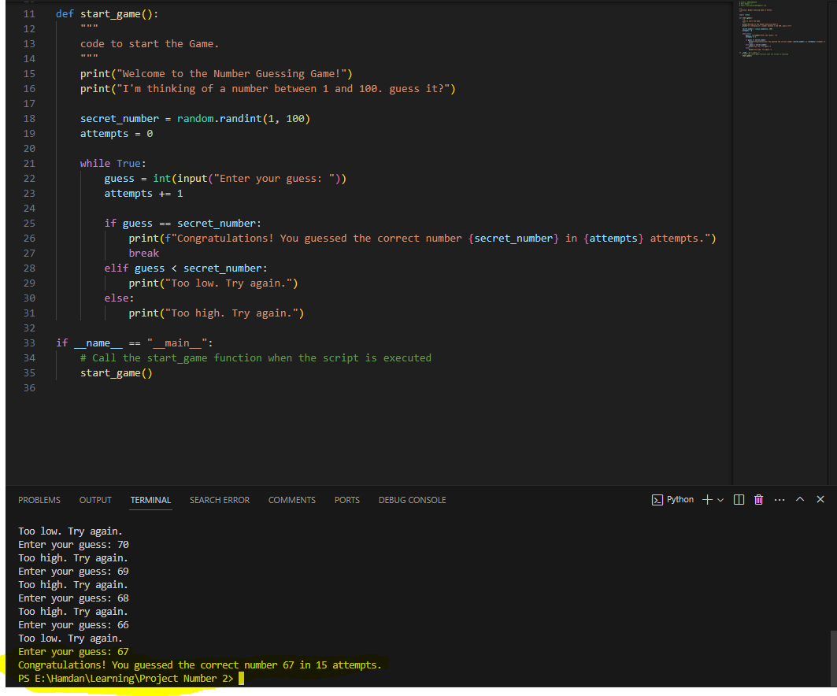

Explanation: You correctly guessed the number, and the game congratulates you.

## Too Low Guess:

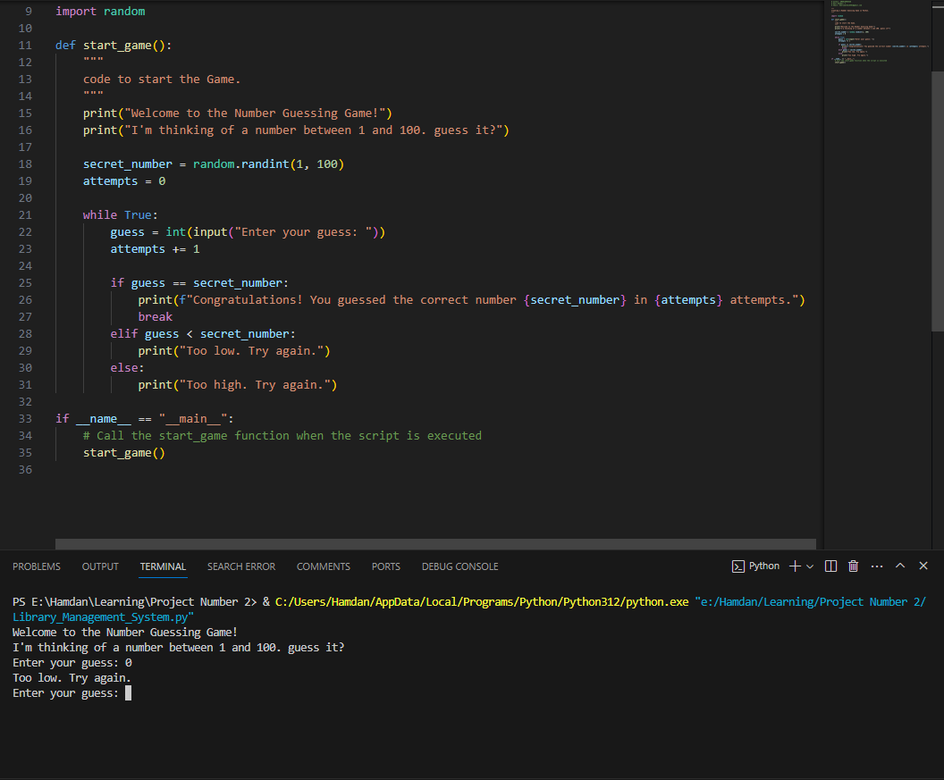

Explanation: Your guess is too low, and the game gives you another attempt to try, guessing correctly.

## Too High Guess:

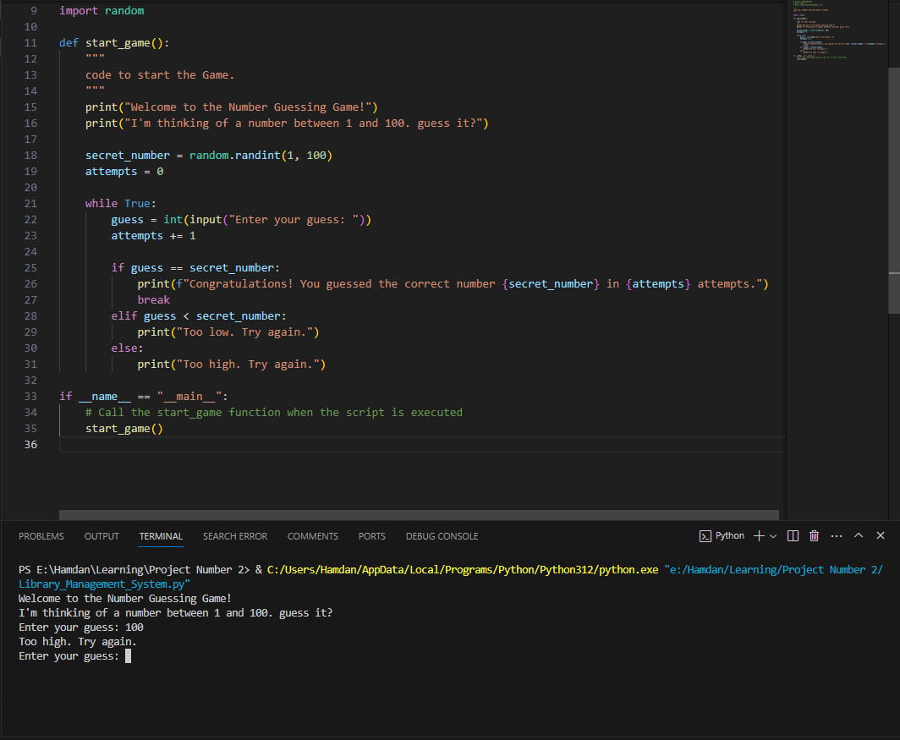

Explanation: Your guess is too high, and the game guides You to try again.

# GitHub Repository

<https://github.com/Umerjamshaid/Umerjamshaid.git>

.